Flow H2O

# Team Name & Team Members

|  |  |  |
| --- | --- | --- |
| **Flow H2O** | | |
| Fu-Yao (Jefferson) | Yu | [fu.yao.yu@hotmail.com](mailto:fu.yao.yu@hotmail.com) |
| Brian | Xu | [xubrianq@gmail.com](mailto:xubrianq@gmail.com) |
| Ankit | Patel | [ankit.p124234@gmail.com](mailto:ankit.p124234@gmail.com) |
| Joshua | Bello | [joshuabello2550@gmail.com](mailto:joshuabello2550@gmail.com) |
| Sannidhya | Desai | [desaisannidhya43@gmail.com](mailto:desaisannidhya43@gmail.com) |

# Product Description

The Flow H2O is a wireless system that tracks the volumetric water discharge from your main water pipe. Real-time data about your water usage, collected by the flow sensor, is sent to your phone, computer, or other device. With this technology, consumers are able to understand when and what utilities around the household use the most water. Having an understanding of their water usage allows users to make better-informed decisions concerning water management, ultimately leading the user to minimize water usage and save the resource.

In the application, users can see data of weekly, monthly, and even yearly water usage. Personalized tips about how to save water are also included in the app. Users can even set a limit on how much water they desire to use in a day and get notifications on the percentage of water they have used in relation to the limit. When the user approaches the daily limit, they are also notified, so that they can minimize their water usage.

The goal of the product is to promote critical judgment to our everyday lives to conserve water, ultimately, saving money, preserving the environment, and unifying society.

# Logo

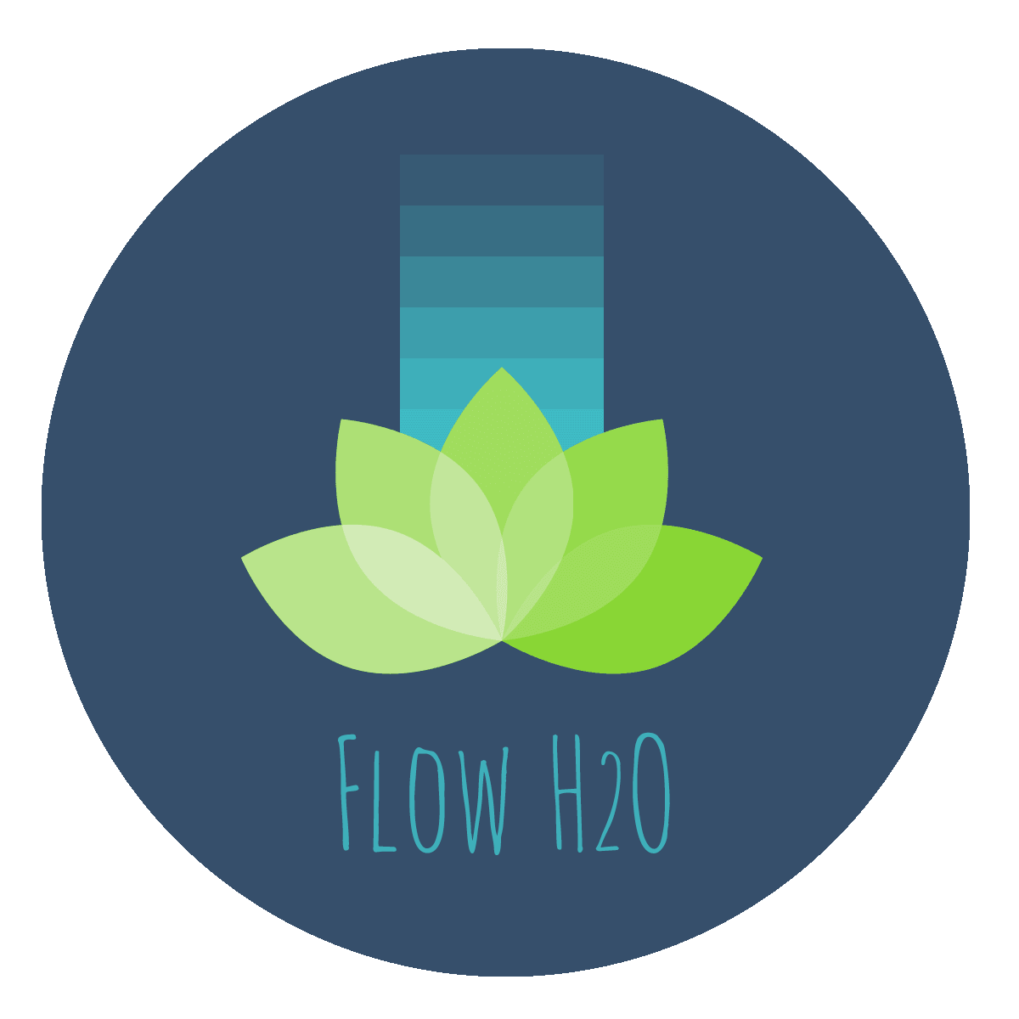

External Link to the Flow H2O Logo (for higher quality download): <https://drive.google.com/open?id=1ke8sbyKKh_3Q-fZ9Dr1PVWL_zbV5gHRO>

# PowerPoint

We will send the link to our PowerPoint when the date gets closer.